Multiple stress tests were conducted on the various webpages of our VR application. This was performed to ascertain how well our application performed under high traffic. To begin testing the art gallery, we had to configure a number of parameters, including the number of threads, ramp up period, and loop count. The loop count and ramp up period were constantly set to 1. The thread count was altered repeatedly to determine the utmost number of concurrent users the art gallery could handle, which was 405. The "threads" refers to the number of concurrent virtual users or requests, "ramp-up period" to the time required to reach the desired number of threads, and "loop count" to the number of times each thread will repeat the requests.

Furthermore, to mimic the number of users accessing the webpage, we set up a HTTP request. The protocol was set to 'http', the IP address was set to '127.0.0.1', the port number was set to '5500', and the path was set to '/VR/Art%20Gallery/art_gallery.html'. To find out the results of the test we used two listeners which were, ‘summary of report’ and ‘view results in table’.

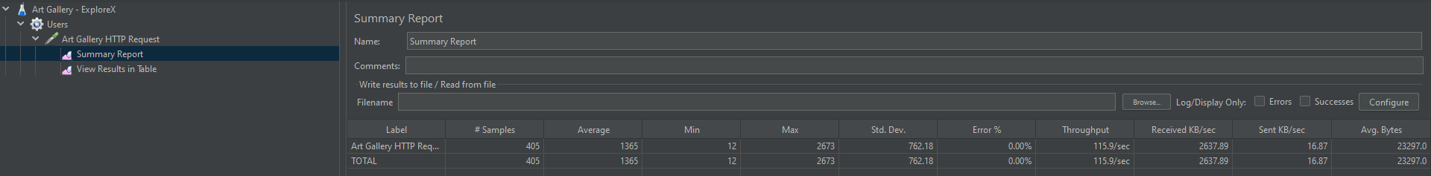In the figure below, we executed the stress test for the art gallery, and the results indicated that it could manage the load of 405 threads. During the stress test, the average response time of 1365 milliseconds represent the expected amount of time required for the application to respond to each request. The standard deviation for response times is 762.18, indicating that some requests took significantly longer to process than others. The error rate of 0% indicates that no errors or failed requests occurred during the test. The throughput of 115.9 requests per second indicates the number of requests processed per second by the web application during the stress test, indicating that the application was able to handle a large number of requests per second, which is a positive result for our application.

FIGURE __: Summary Report for Art Gallery stress test (405 threads)

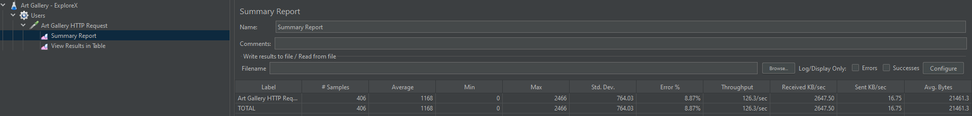In addition, a stress test involving 406 threads was carried out. The results revealed an average response time of 1168 milliseconds, a standard deviation of 764.03 milliseconds, an error rate of 8.87%, and a throughput of 126.3/seconds. The reason for the decline in average response time, the increase in standard deviation, and the rise in error rate is that more threads are accessing the same resources, resulting in either delayed response times or failed requests. Furthermore, the throughput is increased because there are more threads processing requests concurrently.

FIGURE __: Summary Report for Art Gallery stress test (406 threads)

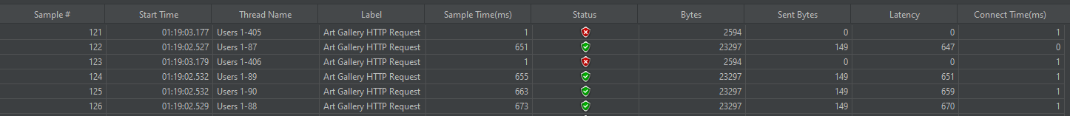

FIGURE __: Results table for Art Gallery stress test (406 threads)

Finally, for the remaining sites, the HTTP request path was modified to correspond to each site, and the thread number was consistently altered to determine the maximum stress load.

**Site 1 Images:**

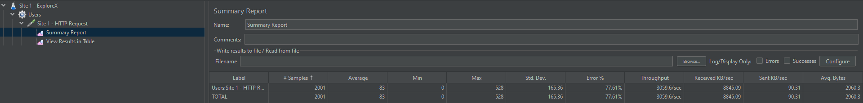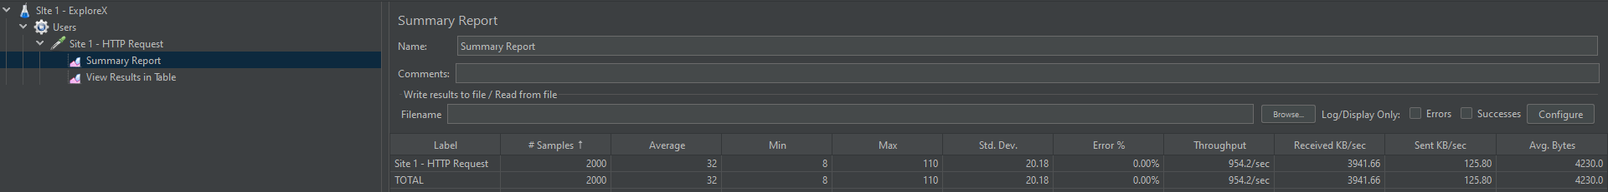FIGURE __: Summary Report for Site 1 images stress test (2000 threads)

FIGURE __: Summary Report for Site 1 images stress test (2001 threads)

FIGURE __: Results table for Site 1 images stress test (2001 threads)

**Site 1 Videos:**

FIGURE __: Summary Report for Site 1 videos stress test (666 threads)

FIGURE __: Summary Report for Site 1 videos stress test (667 threads)

FIGURE __: Results table for Site 1 videos stress test (667 threads)

**Site 2:**

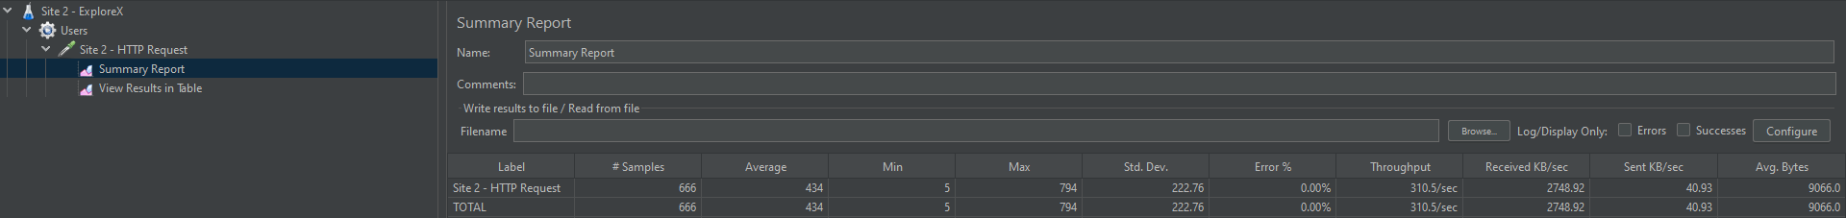

FIGURE __: Summary Report for Site 2 stress test (666 threads)

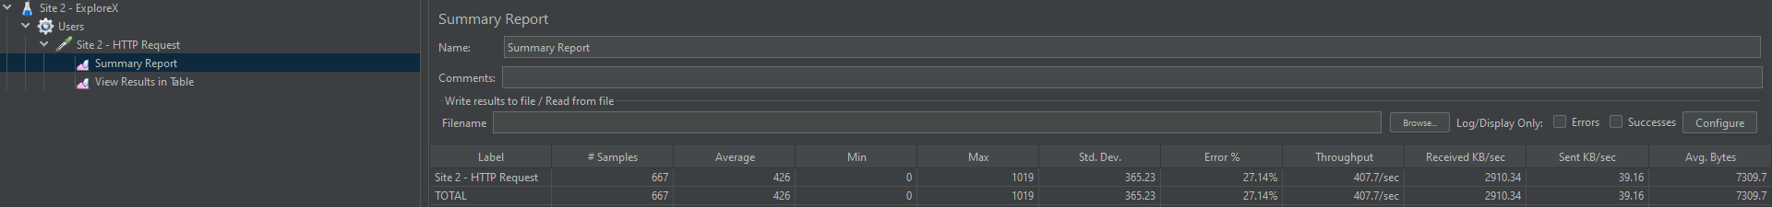

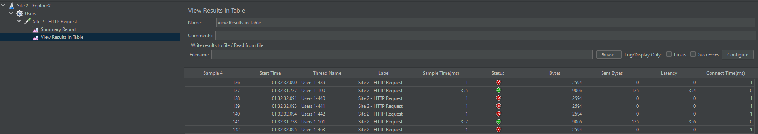FIGURE __: Summary Report for Site 2 stress test (667 threads)

FIGURE __: Results table for Site 2 stress test (667 threads)

**Site 3:**

FIGURE __: Summary Report for Site 3 stress test (666 threads)

FIGURE __: Results table for Site 3 stress test (666 threads)

FIGURE __: Summary Report for Site 3 stress test (667 threads)

**Site 4:**

FIGURE __: Summary Report for Site 4 stress test (666 threads)

FIGURE __: Summary Report for Site 4 stress test (667 threads)

FIGURE __: Results table for Site 4 stress test (667 threads)